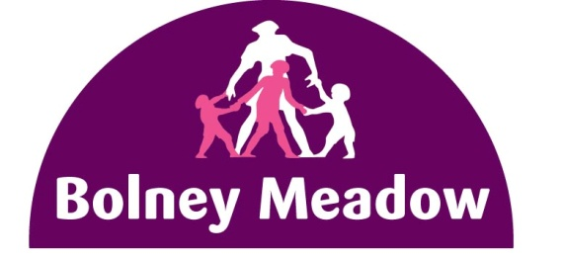
Bolney Meadow “Back to School Grant” 2021
(Bolney Meadow residents only)
Application Form
- The Bolney Meadow Community CIC management board has a small “back to school” grant to assist parents / guardians on the Bolney Meadow Estate pay for, or reimburse either the cost of school uniforms or school supplies for their child / children.

- The terms and conditions are set out below. In order to qualify for the grant you have to:

- be a current resident of Notting Hill Genesis and live on the Bolney Meadow Estate
- have at least one child of school age (between 4 and 16 years old)
- provide your child’s most recent end of term report

- From Monday day 17th August 2021 you can:
- download, complete and email the form to contact@bolneymeadow.com
- download, complete and drop the form in the centre letterbox (situated left of the main entrance)

- The form should be completed by an adult parent, carer, guardian or other authorised person if under the age of 18.

- Subject to availability, parents / guardians will have the choice of four shopping vouchers: Marks & Spencer ꙱ John Lewis ꙱ Next ꙱ ASDA ꙱. Please tick ☑ your preference.

- The grant amount (one per household) is £75.00.

- The grant is limited and therefore the vouchers will be given out on a first come first serve basis until 30th September 2021 or sooner if the vouchers run out before then. There are only 65 vouchers in total.

- Due to concerns with COVID-19 and social distancing rules applicants will have limited timeslots within which to collect their voucher from the community centre (you will be notified by text).

- By completing the online application form for this grant, you are giving permission to BMCCCIC to contact your Notting Hill Genesis housing officer to confirm that you are indeed a current tenant of theirs.

Provide details below
Your child’s age

Full postal address (including postcode)

Parent, carer, or guardian (name as stated on tenancy agreement)

Mobile telephone number
(so we can text you when to pick voucher up)
Do you have your child’s most recent end of term report? Please answer YES or NO (you will need to show a copy of the report when you pick up your voucher

Parent / guardian (please sign below). By signing this form you are giving NHG permission to verify you are their resident.

……………………………………………………………………. …………………………………………………………..
Signed Date
FOR OFFICE USE ONLY – NOT TO BE COMPLETED BY RESIDENT
Notting Hill Genesis housing officer verification / verification date:  - current resident of Notting Hill Genesis and lives on the Bolney Meadow Estate  - have at least one child of school age (between 4 and 16 years old) on tenancy | Verified that resident meets both criteria.  H.O’s name ________________________________________  Date _________________
BMCCCIC’s Approval / date: | Officer’s name _____________________________________  ____________________________ Date _________________
The information that you give on this form will be held subject to the provisions of the Data Protection Act; the data will be shared with authorised personnel of Bolney Meadow Community CIC and will only be used for the purpose of processing your application for the Back to School grant.

